Philadelphia University
Faculty of Information Technology
Department of Software Engineering
Examination Paper
Lecturer: Ms. Enas Naffar
Coordinator: Ms. Enas Naffar
Internal Examiner: Dr. Mourad Maouche

721110: Introduction to Software Engineering
Section: 2
Final Exam, Time: 120 Minutes

Information for Candidates
- This examination paper contains 5 questions, totalling 40 marks.
- The marks for parts of questions are shown in round brackets.

Advice to Candidates
1. You should attempt all questions.
2. You should write your answers clearly.

I. Basic Notions
Objectives: The aim of the questions in this part is to evaluate the required minimal student knowledge and skills. Answers in the pass category represent the minimum acceptable standard.

Question 1: (10 Marks)
Select the best answer for the following multiple choice questions:

1- What does a software architecture describe?
A-The system as a whole.
B-The system's parts and how they are built.
C- The system as a whole, its parts and how parts communicate.
D-The system's parts and how they behave at run-time.

2- Which of the following is true regarding a use case?
A- It should describe in detail an aspect of the user interface of the system
B- It has a series of steps, some done by the system and some by the actor
C- There is always an alternative scenario.
D- It helps in the requirement phase only Black box testing can be called:

3- Black-box testing can be called:
A-dataflow testing
B-loop testing
C-behavioral testing
D-graph based testing

4- Cohesion is a qualitative indication of the degree to which a module
A- can be written more compactly.
B- focuses on just one thing.
C- is able to complete its function in a timely manner.
D- is connected to other modules and the outside world.

- Coupling is a qualitative indication of the degree to which a module
A- can be written more compactly.
B- focuses on just one thing.
C- is able to complete its function in a timely manner.
D- is connected to other modules and the outside world.
6- SRS stands for: D) is connected to other modules and the outside world.SRS refer to:
- Software Requirements Specification.
- System Resources Statement.
- Statement of Reliability of System.
- Standard Requirements Statement.

7- Suppose we have an application that consists of 200 lines of code using the Java programming language and assume the development personnel are paid at a rate of $5,000 per staff month. And suppose that coding took only 1 staff/ week, but the production of paper documents remained constant at 1 staff/ month the Productivity will equal:
A- 250 LOC per month.
B- 160 LOC per month.
C- 25 LOC per month.
D- 100 LOC per month

8- A generalized description of a collection of similar objects is a
A- Instance
B-Class
C- Subclass
D- None of the above jjkkhkjasda
A) class
9- A Software is a set of:
A-data, hardware, programs, people, procedures
B-data, documentation, people, programs
C-data, procedures, programs, documentation
D-people, procedures, data, hardware

10- Studying the needs of users and any information the system currently uses is called:
A-System analysis
B-System design
C-Functional requirement
D-user interface
B) data, documentation, hardware, software
C) data, hardware, software, procedures
D) documentation, hardware, people, procedures A) data, hardware, software, people
B) data, documentation, hardware, software
C) data, hardware, software, procedures
D) documentation, hardware, people, procedures A) data, hardware, software, people
B) data, documentation, hardware, software
C) data, hardware, software, procedures
D) documentation, hardware, people, procedures B) instance
C) subclass
D) super class
II. Familiar Problems Solving
Objectives: The aim of the questions in this part is to evaluate that the student has some basic knowledge of the key aspects of the lecture material and can attempt to solve familiar problems

Question 2: (15 marks)

You are designing the access control policies for a Web-based retail store. Customers access the store via the Web, browse product information, input their address, and payment information, and purchase products. Suppliers can add new products, update product information, and receive orders. The store owner sets the retail prices, makes tailored offers to customers based on their purchasing profiles, and provides marketing services.

- Write five functional requirements of the system. ( 5 marks)
- Draw the architecture of the system using three tiered architecture (6 marks)
- Draw the Class diagram of the system, assuming that the system has the following classes: Customer, Supplier, Product, Order (4 marks)

Question 3: (5 marks)
Consider the following structured chart then fill the table below with the correct module name:

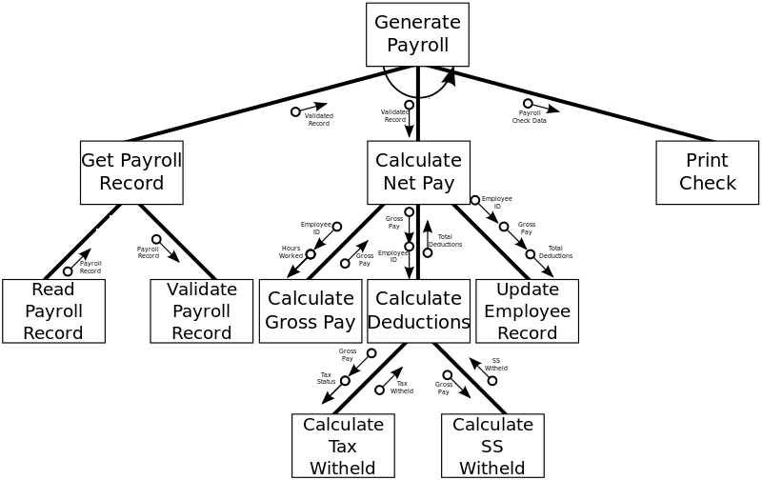
Input module | Output module | Coordination module | Transform module | Composite module

Question 4: (3 marks)
Consider the following diagram then answer the questions below:

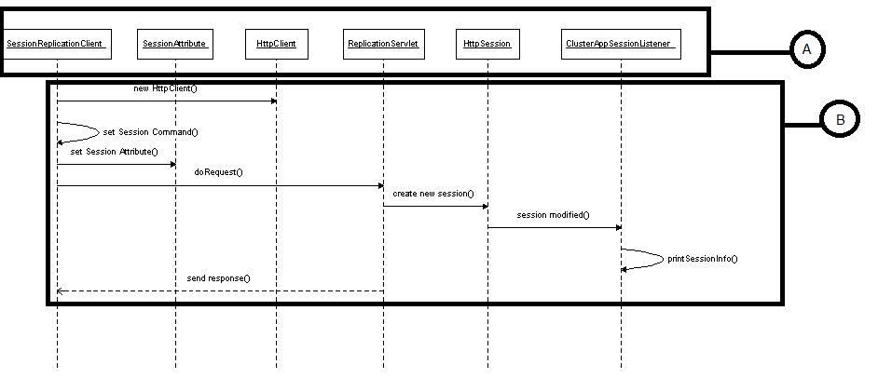

- This diagram is called ……….
- The elements indicated by the letter A represent …..
- The arrows indicated by the letter B represent….

- Unfamiliar Problems Solving
Objectives: The aim of the questions in this part is to evaluate that the student can solve familiar problems with ease and can make progress towards the solution of unfamiliar problems, and can set out reasoning and explanation in a clear and coherent manner.

Question 5: (7 Marks)
Write down the test cases for the following program:

a = Read(b)
c = 0
while (a > 1)
{
If (a^2 > c)
c = c + a
else
a = a – 2
}
If ( a==1)
print a

Good Luck ☺

